Native American Mathematics Integrative Lesson for
Mathematics for Elementary Education Teachers Course

SESSION TITLE:
Developing Materials Needed to Play Hand Games (Lesson 10)
INTEGRATION POINT EXAMPLE GUIDEPOST:
Measurement
APPROXIMATE LESSON TIME:
2 – 50 minute modules

FOCAL MATHEMATICAL CONTENT
1. History of the Hand Games
2. Measuring in English Units

GOALS OF THE SESSION
Students who complete this lesson will be able to:
1. Appreciate the history of the Hand Games as it relates the Native American culture.
2. Understand the use of each piece of game equipment
3. Design game pieces used in the playing of Hand Games
4. Use English units of measure to construct game pieces used in the playing of Hand Games

METHODS OF INTEGRATION INTO ESTABLISHED COURSE
Examples of points of integration are most naturally found in teaching measurement in a Math for Elementary Teachers course. The mathematical concepts discussed in this lesson include measuring in English units. This lesson will supplement this topic by presenting a brief history the Native American Hand Game and using measuring skills to construct the game pieces used in the Hand Games.
MULTIPLE REPRESENTATIONS
1. Stories describing the Native American Hand Game pieces.
2. Drawings of the pieces used in Native American Hand Games.
3. Physical models of pieces used in Native American Hand Games.
4. Students creating their own Hand Game pieces.

SESSION – RELATED QUESTIONS FROM THE INSTRUCTOR
1. What is one reason Hand Games are played?
2. What is the purpose of the songs in the playing of Hand Games?
3. What game pieces are needed to play Hand Games?
4. Describe what each Hand Game piece is used for.

INBEDDED ASSESSSMENT OPPORTUNITIES
These include but are not limited to
1. Session activities in which students are presented with Hand Game pieces and can analyze and interpret marking on them
2. Students will present Hand Game pieces to each other
3. Students will design and construct Hand Game pieces using given measurements
4. Students will create pictorial representations of their designed Hand Game pieces and label them correctly with measurements
5. Students will complete assigned activities

SESSION – RELATED STORIES

Hand Game and Native Cultures

The Hand Game is an ancient game within North American Native cultures that pre – dates contacts from other cultures. Through the Hand Game, stories and songs could, and still are shared. The Hand Game brought people together from within a tribe and also from different tribes. The gathering of the people inevitably encourages the exchange of stories, whether it was information about friends and relatives, passing on of myths, or information about the different tribes, the topics for conversion were limitless.

The singing that accompanies the Hand Game had connotations that were mostly of a mythological nature. The songs that were used were believed to have mythological powers and if a group sings its songs and won the game then it was believed that the group had more power than the opposing team. Their powerful song was believed to have made them succeed.



History of the Hand Game

Some of the mythology that surrounds the origins of the Hand Game centers on the coyote that is perceived as a hero, or a trickster by various tribes, depending on the region and the myths that coyote is associated with. Coyote is believed to be the assistant of the Creator and was sent to the earth to prepare it for the coming of the North American Native people. In many myths of the North American natives, the coyote is involved with playing games of chance, the main game of choice being the Hand Game.

The singing that accompanies the Hand Game had connotations that were mostly of a mythological nature. The songs that were used were believed to have mythological powers, and if a group sang its songs and won the game then it was believed that the group had more power than the opposing group. The powerful song made them succeed. These songs were passed down many generations. The songs that were sometimes sung were used to try to instill fear in the opponents, and some songs were used in order to taunt a group. The drums are played to keep to the rhythm of the song or game, but this is a recent addition to the Hand Game.

The Hand Game was a game that was also played for the exchange of goods. The North American Native people used the game to exchange different foods that were found in different regions, land, horses, textiles, trinkets, and household goods were used for exchange. The way these items were exchanged was that items of equal value were matched against each other. In order to match there had to be two opposing teams and each team had a variable amount of players. The amount of players on a team was limitless. The contemporary mode of exchange is monetary with an increasing focus on paper money at various Hand Games to date.

A. INSTRUCTOR MATERIALS
Print Materials
- Narrative on the history of Hand Games
- Diagrams of game pieces used in Hand Games
- Transparencies of game pieces used in Hand Games

Equipment
- Overhead projector

B. PARTICIPANT MATERIALS
Print Materials
- Handout on Developing Materials Used In Hand Games
For General Class Use
- Ruler
- Paper Punch (participants may share)
- Scissor
- Markers
- Colored Pencils
- Yarn
For each participant
- Large Piece of Cardboard (4’-5’ long and 3” wide)
- 1 piece of cloth 20” square
- 1 stick (use a dowel) 15” long by ½” thick
- 1 piece of cloth 6”-7” square
- 4 dowel pieces 3 ½” long each
- 10 dowel pieces 10”-12” long each
- 1 dowel piece 14”-15” long
- 1 piece of cloth 20” by 12”
- strips of cloth for fringe
- beads for decoration
C. SESSION OVERVIEW
- During the lesson on measurement, student interest in Native American Hand Games will be introduced
- Brief history on Native American Hand Games will be discussed
- Pictures of Hand Game pieces will be introduced
- Construction of Hand Game pieces will be discussed
- Students will construct Hand Game pieces with correct dimensions as given in the lesson
- Students will analyze and discuss the construction process including the mathematical ideas involved
- Problems assigned from general lesson and Native American Hand Games lesson will be assigned

D. SESSION NOTES
1. Make sure you have sufficient materials and equipment for student use.
2. Allow ample time to discuss the history and background of Native American Hand Games.
3. Consider having Native American presenters come to discuss the Hand Game.
4. Note that in the Activity Directions, the Native American cultural connections are intertwined with the construction instructions.

DO NOW
1. Discuss the background and history of the Native American Hand Game.
2. Display models of the Hand Game pieces which are used and which will be constructed.
3. Complete Activity Sheets (which follow)

DO AS PREPARATION FOR OUR NEXT SESSION
1. Use print or web technology to investigate Native American Hand Games.
2. Prepare a report on Native American Hand Games which shows various materials used by tribes throughout North America.

Activity Sheet
“Developing Materials Needed to Play Hand Games”

The traditional culture of the Ojibwa people of North America is full of meaning, mythology and mathematics. The Native American Hand Game is a concrete example of how all of these ideas are intertwined. The game pieces and drums used for the Hand Game are constructed using a combination of measurement skills from mathematics along with the materials gathered from nature.

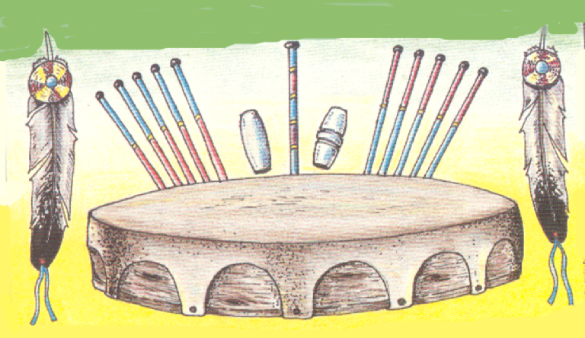

In this activity, you will design and construct the pieces needed to play a Hand Game. These pieces include a hand drum with stick, the bones for the Hand Game, the Hand Game sticks, and a bag for the Hand Game sticks.

Step 1 – Construction of the Hand Drum

Materials:
Elk hide approximately ½ hide, belly cut. (Use a 20” square piece of cloth)
3 yds raw hide sinew for stringing drum. (Use Yarn)
1 Ash tree for the casing, 3 inches wide and 32 inches long. (Use cardboard)

After offering tobacco, cut the Ash tree down and peel the bark and shave off all the knots and cut out the straightest part of the tree. Cut one long piece about 4 or 5 ft long (usually the center of the tree). With a sander, rasp or planer, shave the straight part of the tree until you get the proper thickness, which is about 1 and ½ inches thick. You will need to soak in water the part you are going to use for the drum frame. After soaking in water, the straight part of the tree you have shaved will become soft so you can bend it into a circle and start putting the drum together. (Use a piece of cardboard to construct a circle)

You will need to punch 16 or more holes for the sinew, which is used to hold the elk hide in place for the face of the hand drum. You will need use the 3 yds of sinew and start in the center at the back of the drum bringing the lacing towards the outer edge of the drum frame and hide lacing hole to hole until you come to the hole you started and take back to the center back of the hand drum. When you are finished lacing you will have a circular piece of all the sinew that was used and this will be used as a handhold. (Use yarn for the sinew)
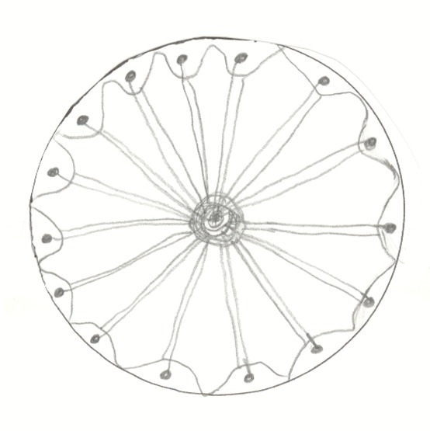
Diagram of bottom when completed:

Step 2 – Construction of the Drum Stick

Materials:
1 stick 15” long. (Use a wooden dowel)
1 square piece of leather 6”-7” square. (Use a piece of cloth)
1 32” piece of sinew (Use yarn)

This stick should be very straight (from the branches of the Ash tree). You will shave off the small knots until you have a nice straight stick. From this you cut a section that is about 15 inches long and you start making the head for your stick. The head will need a clean square piece of leather that has no holes (leftover elk hide scraps from the piece that was used for the drum). The piece of hide should be about 6 or 7 inches square. In the center of the square piece of leather you will put soft cotton or yarn, you bunch it up until it is very firm but soft. You put the drumstick in the center and start tying it with sinew which is about 32 inches long. You go around and around the head until you are confident that it will not fall out when you are using the drumstick.
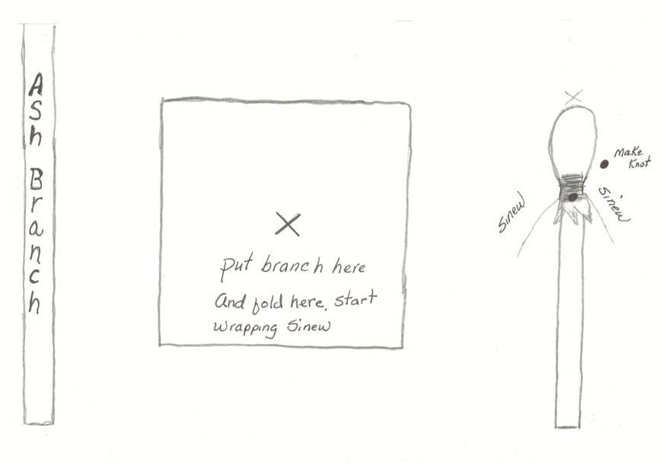
Diagram:

Step 3 – Construction of the Bones

Materials:
4 sticks 3 ½” long. (Use wooden dowels)

Hand Game is a guessing game which players of one team hide small bones in their hands and one player from the opposing team try to guess which hand the correct bone is in.
The bones can be made with the leftover branches from the Ash tree for they are only about 3 ½ inches in length. Two of the bones have painted stripes around the center and are called the male bones. They carry no value and are used to merely confuse the opponent. The other two bones are plain and if you guess these bones you win the game. There are a total of 4 bones.

The 4 bones can also be made with Elk or Deer horns, silicone from the store, but this is very hard if you want a nice set of bones. Some people use Willow trees for the bones and sticks in this game of chance.

Diagram:
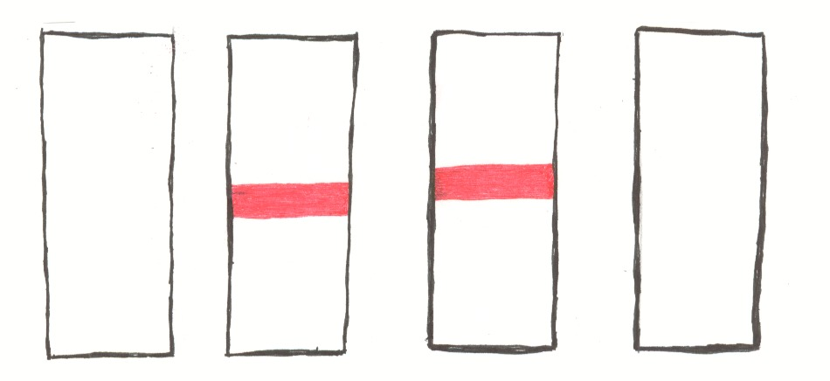

Step 4 – Construction of the Hand Game Sticks

Materials:
10 sticks 15” long. (Use wooden dowels)
1 stick 18” long. (Use wooden dowel)

A small Chokecherry or Willow tree is usually used to make the sticks. Cut the branches into 15 inch lengths and one branch about 18 inches long. With a sander or sand paper you sand all branches as smooth as you can and you begin to cut out your sections for the Hand Game sticks.
There are 10 Hand Game sticks that are used. These sticks are used to keep score and they are usually 10 to 12 inches long and they are about the size of your index finger. There is also 1 kick stick. A set of 5 of the Hand Game sticks is beaded or decorated one color and one set of 5 is decorated a different color.
The kick stick is 14 to 15 inches long. The kick stick is painted or beaded to match the other 10 Hand Game sticks.

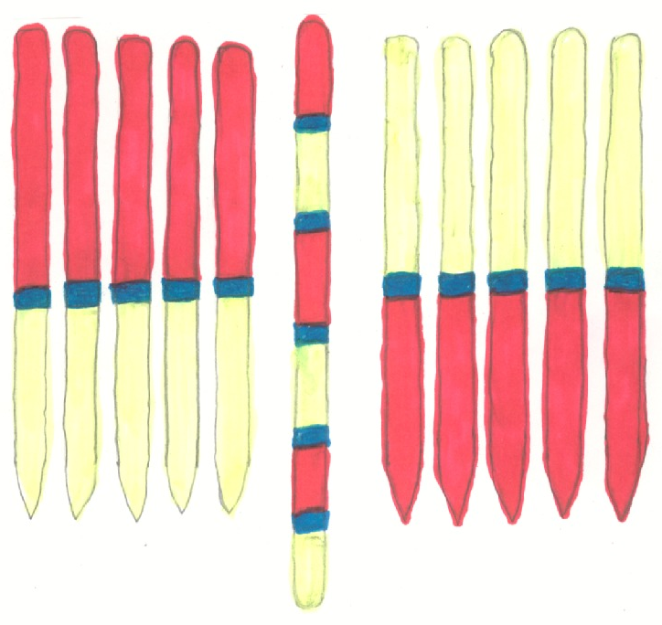
Diagram:

Step 5 – Construction of the Bag for the Hand Game Sticks

Materials:
1 strip of leather 20” by 12”. (Use cloth)
2 yds of sinew. (Use yarn)
4”-5” of leather for the fringe (Use cloth)
8-10 beads for decoration
1 strip of leather 18” long (Use yarn)

From the scrapes of the leather you used to make the Hand Game drum you might get 1 strip of leather.

This strip should be 20 inches long and 12 inches wide. You will need 2 yds of sinew for the edges. You need 4 or 5 inches of leather for the fringe at the bottom of the bag. You also need about 8 or 10 crow beads for decoration. You need a strip of leather for closing the bag shut. This strip of leather should be about 18 inches long

At the top of the leather that is 12 inches wide, you will sew the edge with the sinew to make a small hem. Fold over the leather that is 20 inches long and start sewing with the sinew, top to the bottom of the bag you are making.

At the bottom of the bag you attach the fringe you made from the 4 or 5 inches of leather. Leaving a strip at the top to hold the fringe together, cut vertically every ½” until you have cut all the leather. You can string the crow beads to the fringe. Sew the bottom the same way you sewed the sides.

You can also string some crow beads to the strip of leather for closing the bag.

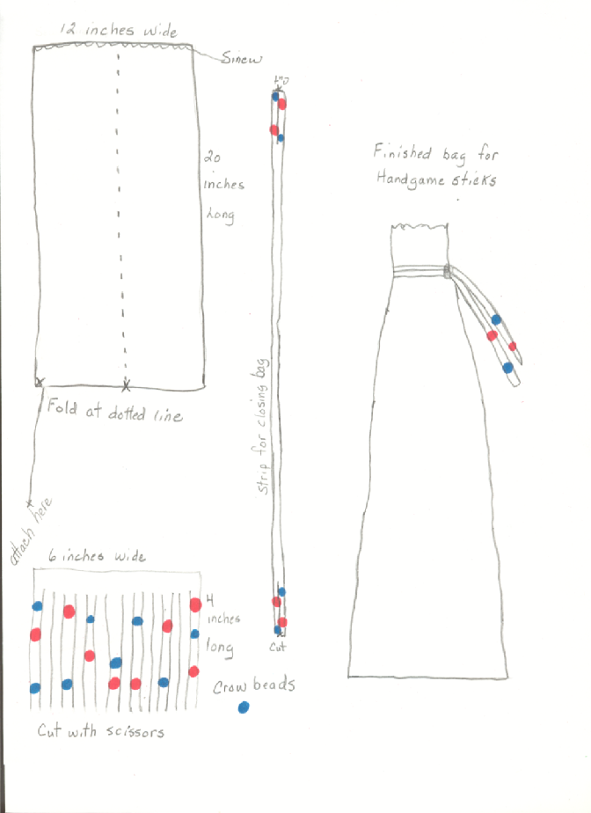
Diagram:

Discussion and Questions:

1. What are the reasons Hand Games are played?

2. What is the purpose of the songs in the playing of Hand Games?

3. What are the pieces of equipment needed to play Hand Games?

4. What is each piece of equipment used for?

5. What mathematical concepts were used in the construction of the Hand Game pieces?

